SIMATS ENGINEERING
ASSESSMENT TOOL
COURSE NAME: Theory of Computation
COURSE CODE: CSA1304

COURSE OUTCOME COVERED
CO1: Analyse fundamental mathematical concepts of automata theory for formal languages and decision problems (BL:3)
Assessment Tool Weightage: 20%
QUESTIONS: 5 Total Marks:25
Duration: 1 Hour
Simulation
Code of Conduct:
I S. Harish (192511119) (Name / Reg No) certify that this submission is my original work and that I have adhered to the guidelines specified for this assessment.
I understand that any violation of academic integrity rules will result in disciplinary action.

Signature of the student:

SIMATS ENGINEERING
ASSESSMENT TOOL
- Design a Non-Deterministic Finite Automaton (NBA) for an Automatic Door System based on sensor inputs. An automatic door system can be modelled using an NBA to represent different states and transitions. The system consists of four states: Closed, Opening, Open, and Closing. The input symbols are P (Person detected) and N (No person detected). Initially, the door is in the Closed state. When a person is detected (P), the system may non-deterministically transition from Closed to Opening. Once opened, the system moves to the Open state. If no person is detected (N), the door transitions to Closing and eventually returns to the Closed state. Non determinism occurs when the system may remain in the Open state even if a person is detected or may start closing if no detection occurs.

SOLUTION:
Design
- Closed → Opening: on P, the door may start opening, or it may stay Closed. This is one source of nondeterminism.
- Opening → Open: once the door has opened, it moves to Open on either input.
- Open: on P it stays Open. On N it may stay Open or start Closing, which is the second source of nondeterminism.
- Closing → Closed: on N, the door finishes closing.

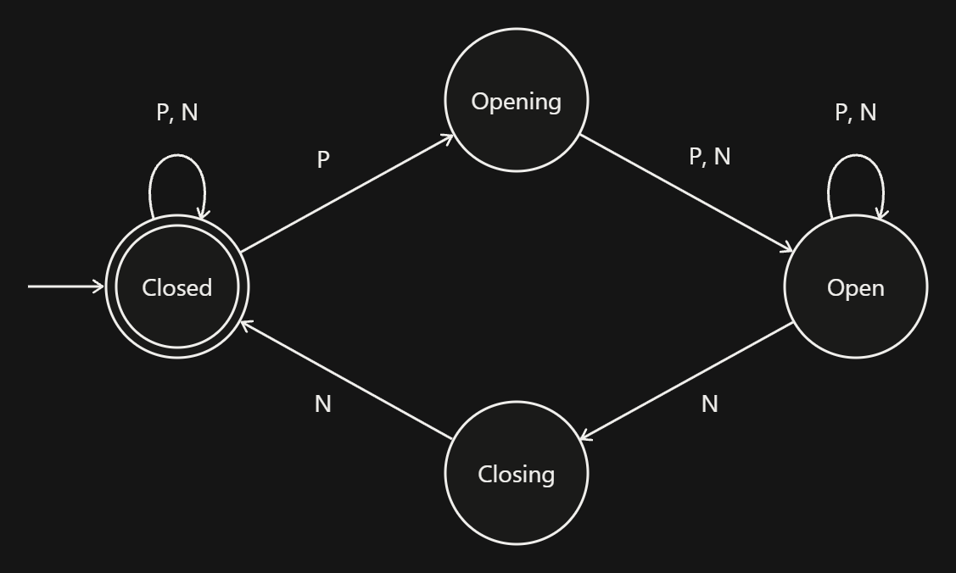

Formal definition
M = (Q, Σ, δ, q0, F), where
- Q = {Closed, Opening, Open, Closing}
- Σ = {P, N}
- q0 = Closed
- F = {Closed}

State | P | N
→ * Closed | {Closed, Opening} | {Closed}
Opening | {Open} | {Open}
Open | {Open} | {Open, Closing}
Closing | ∅ | {Closed}

The nondeterminism shows in two places. From Closed on P, the door may open or stay shut. From Open on N, it may stay open or start closing.
One accepting path is Closed –P→ Opening –P→ Open –N→ Closing –N→ Closed.
Tracking all possible states together:

Symbol read | Set of current states
(start) | {Closed}
P | {Closed, Opening}
P | {Closed, Opening, Open}
N | {Closed, Open, Closing}
N | {Closed, Open, Closing}

- Design a finite automaton to model a traffic light control system at a road intersection. The automaton should represent different states corresponding to the traffic lights, such as Red, Green, and Yellow. Define the transitions between these states based on a timer or control signals, ensuring that the sequence follows the standard order (Red → Green → Yellow → Red). Include considerations for timing constraints, such as how long each light remains active, and describe how the automaton handles continuous cycling of signals. Additionally, explain how this model can be extended to handle pedestrian crossing signals or emergency vehicle overrides, ensuring safe and efficient traffic flow.
SOLUTION:
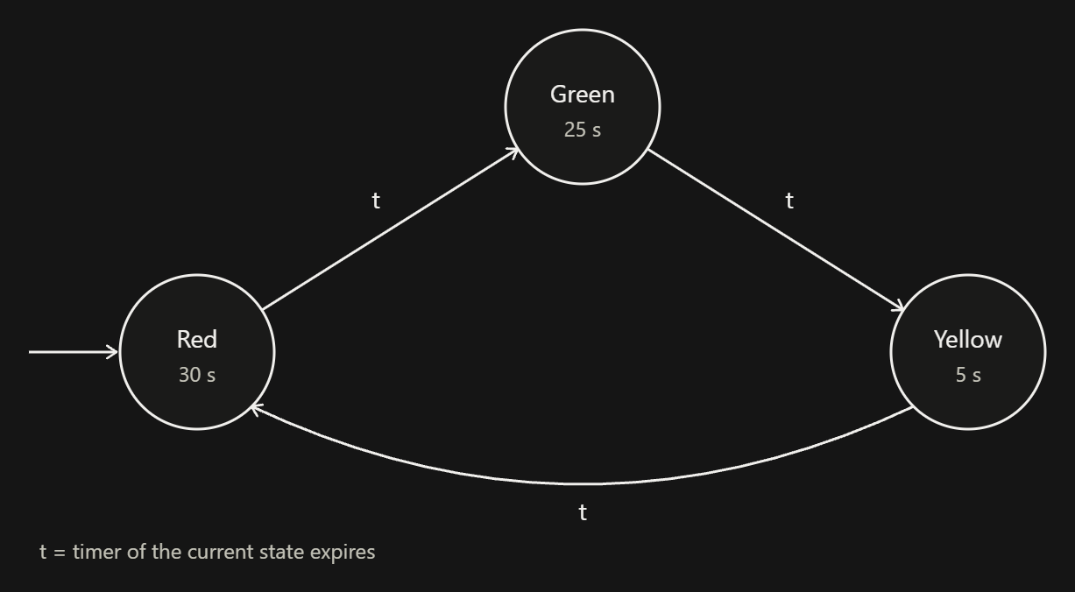
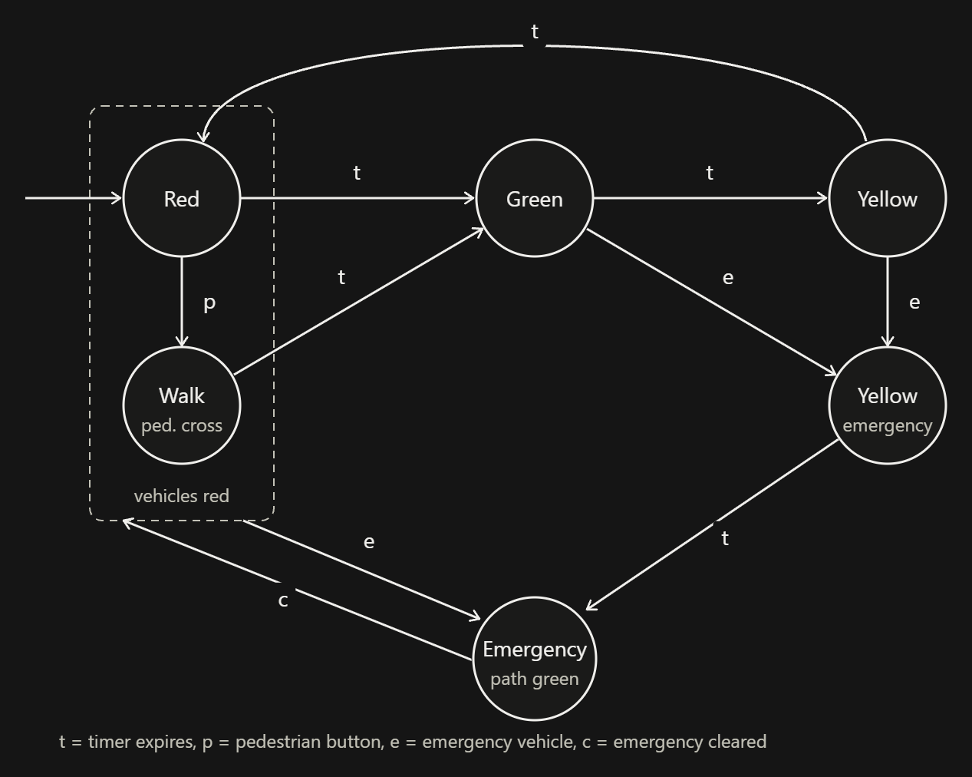

State | t | p | e | c
→ Red | Green | Walk | Emergency | Red
Walk | Green | Walk | Emergency | Walk
Green | Yellow | Green | Yellow-emergency | Green
Yellow | Red | Yellow | Yellow-emergency | Yellow
Yellow-emergency | Emergency | Yellow-emergency | Yellow-emergency | Yellow
Emergency | Emergency | Emergency | Emergency | Red

How this keeps traffic safe and efficient:
- Pedestrians: The button press is only honoured in Red, where p takes the machine to Walk. Walk and Green are different states, so pedestrians and vehicles can never be released together. In Green or Yellow the press is ignored by a self-loop. In a real controller the press would be stored in a flag so that Red goes to Walk at the next red phase.
- Emergency vehicles: From Red or Walk, e goes straight to Emergency. From Green or Yellow, e goes first to Yellow-emergency, which gives the usual yellow clearance of at least 5 s before Emergency, so a green is never cut off abruptly. When c arrives, Emergency returns to Red, so normal operation always restarts from a safe red.
- Efficiency: The emergency path is held only while e is true. After that the normal 60 s cycle resumes, and each state keeps its own timer.
- Real intersections: Two crossing roads can be modelled as two copies of this automaton run in parallel (a product automaton). Transitions into Green are allowed only when the other road is in Red, which guarantees that conflicting greens never occur.

- Design DFA using simulator to accept the string the end with ab over set {a,b) W= aaabab
SOLUTION:

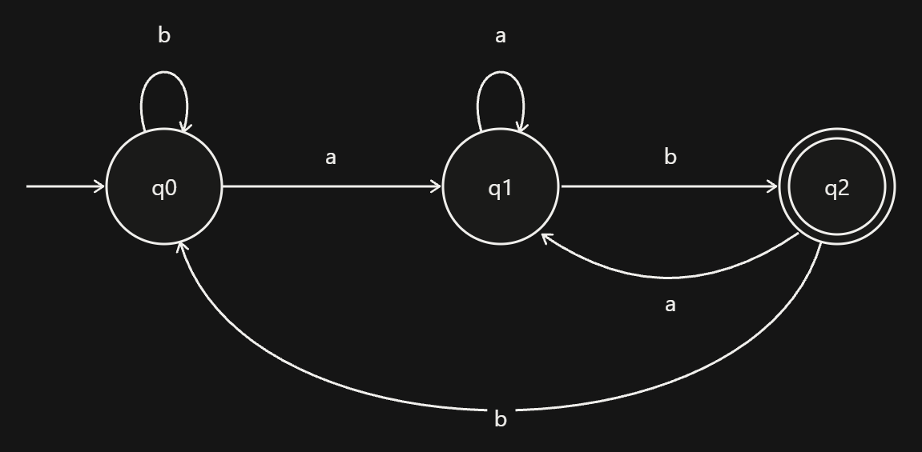
Formal definition
M = (Q, Σ, δ, q0, F), where Q = {q0, q1, q2}, Σ = {a, b}, the start state is q0, and F = {q2}.
State | a | b
→ q0 | q1 | q0
q1 | q1 | q2
* q2 | q1 | q0

Simulating w = aaabab
Step | Symbol read | Move | Current state
0 | (start) |  | q0
1 | a | q0 → q1 | q1
2 | a | q1 → q1 | q1
3 | a | q1 → q1 | q1
4 | b | q1 → q2 | q2
5 | a | q2 → q1 | q1
6 | b | q1 → q2 | q2

The whole string is read and the DFA ends in q2, which is the final state. So aaabab is accepted, because it ends with ab.

- Design a Deterministic Finite Automaton (DFA) using a simulator to accept only the input strings “c”, “bc”, and “bcaaa” over the alphabet {a, b, c}. The automaton should begin from an initial state and transition through intermediate states based on the sequence of input symbols, ensuring that each valid string follows a unique path. For example, the string “c” should be accepted directly from the start state, while “bc” should pass through states representing “b” and then “c”. Similarly, “bcaaa” should be processed through a sequence of states that track each additional “a” after “bc”. Any deviation from these exact patterns should lead to a dead state, ensuring that no other strings are accepted. Clearly define the states, transition functions, start state, and accepting states, and implement the DFA in a simulator such as Autosim to verify its correctness.
SOLUTION:
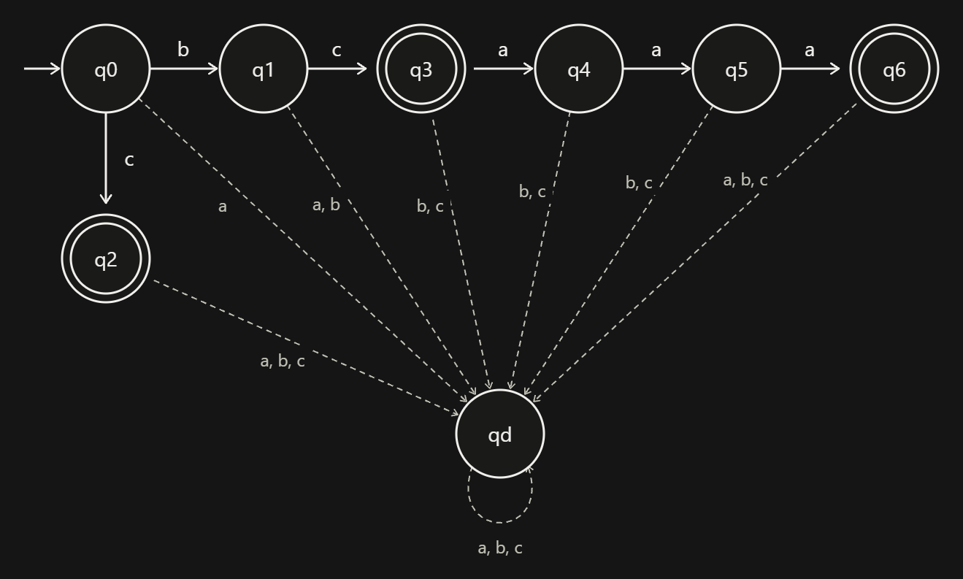
States and their meaning
State | Meaning (input read so far)
q0 | nothing read (start)
q1 | b
q2 | c (accepting)
q3 | bc (accepting)
q4 | bca
q5 | bcaa
q6 | bcaaa (accepting)
qd | dead state (trap)

Formal definition
M = (Q, Σ, δ, q0, F), where
- Q = {q0, q1, q2, q3, q4, q5, q6, qd}
- Σ = {a, b, c}
- q0 is the start state
- F = {q2, q3, q6}

State | a | b | c
→ q0 | qd | q1 | q2
q1 | qd | qd | q3
* q2 | qd | qd | qd
* q3 | q4 | qd | qd
q4 | q5 | qd | qd
q5 | q6 | qd | qd
* q6 | qd | qd | qd
qd | qd | qd | qd

Verification
Input | Path | Result
c | q0 → q2 | accepted
bc | q0 → q1 → q3 | accepted
bcaaa | q0 → q1 → q3 → q4 → q5 → q6 | accepted
bca | q0 → q1 → q3 → q4 | rejected (q4 is not final)
bcaaaa | … → q6 → qd | rejected
cc | q0 → q2 → qd | rejected
ε | q0 | rejected (q0 is not final)

- Design a Deterministic Finite Automaton (DFA) using a simulator to accept all strings over the alphabet {a, b} that begin with either “a” or “b”. The automaton should start in an initial state and immediately transition to an accepting state upon reading the first input symbol, since any valid string must start with either “a” or “b”. After the first symbol is processed, the DFA should remain in an accepting state regardless of the subsequent sequence of “a” and “b”, thereby allowing any combination of characters to follow. Additionally, include a dead state to handle invalid or empty inputs if required by the simulator. Clearly define the states, transition rules, start state, and accepting states, and verify the design using a simulator such as Autosim to ensure that all valid strings are accepted and invalid ones are rejected.
SOLUTION:
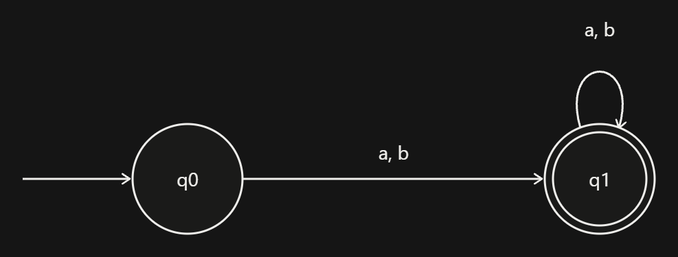
Formal definition
M = (Q, Σ, δ, q0, F), where Q = {q0, q1}, Σ = {a, b}, the start state is q0, and F = {q1}.
State | a | b
→ q0 | q1 | q1
* q1 | q1 | q1

- q0 is the start state and is not accepting, so the empty string is rejected.
- q1 is the accepting state. Once the first symbol has been read, the DFA stays in q1 whatever follows.

Dead state
Over the alphabet {a, b} the transition table is already complete, so no dead state is needed. Even the empty input is handled by q0 not being final. If your simulator uses a larger alphabet such as {a, b, c}, add a state qd with q0 –c→ qd, q1 –c→ qd and qd looping on a, b, c. That keeps strings containing c rejected.
Verification
Input | Path | Result
a | q0 → q1 | accepted
b | q0 → q1 | accepted
abba | q0 → q1 → q1 → q1 → q1 | accepted
bbb | q0 → q1 → q1 → q1 | accepted
ε (empty) | q0 | rejected

SIMATS ENGINEERING
ASSESSMENT TOOL

RUBRICS FOR CALCULATION:
Criteria | Weightage | Level 4 –  Exemplary (5 Marks) | Level 3 –  Proficient (4 Marks) | Level 2 –  Developing (2–3 Marks) | Level 1 –  Beginning (0– 1 Mark)
Conceptual  Understanding | 30 | Demonstrates clear and  complete  understanding of the concept | Good  understanding with minor  gaps | Basic  understanding with some  misconceptions | Poor or  incorrect  understanding
Accuracy of Answer | 25 | Completely  correct answer with no errors | Mostly correct with minor  errors | Partially correct with noticeable errors | Incorrect or  irrelevant  answer
Application of Knowledge | 20 | Correctly applies concepts to  solve the  question/proble m | Applies  concepts with minor mistakes | Limited or  partially correct application | No or incorrect application
Completeness of Response | 15 | Covers all  required parts of the question | Covers most parts with  minor  omissions | Covers only some parts | Incomplete or missing  response
Clarity &  Presentation | 10 | Clear, concise, and well  organized  answer | Understandabl e with minor issues | Somewhat  unclear or  poorly  structured | Difficult to  understand

